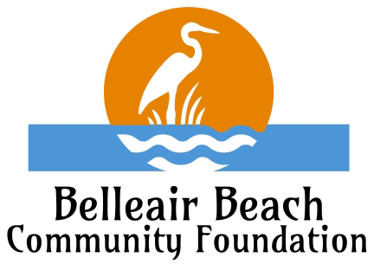
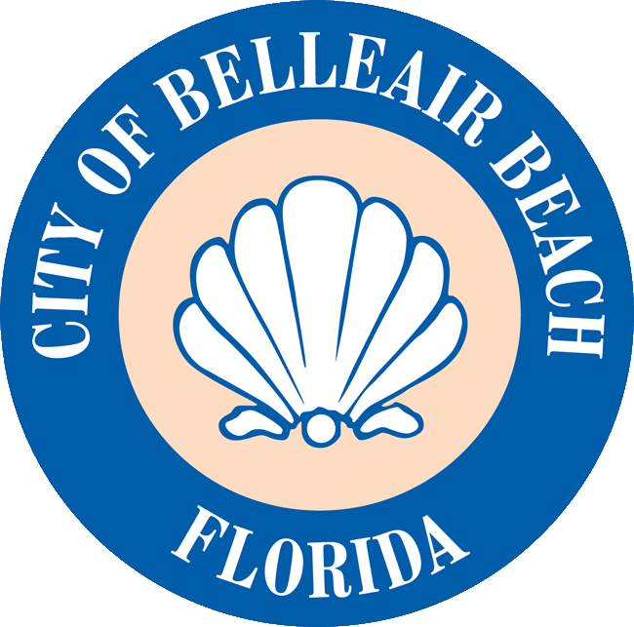

City of Belleair Beach
Adopt A Park Program Agreement

The City of Belleair Beach (“City”) in association with the Belleair Beach Community Foundation (“BBCF,” together with the City, the “Entities”), offer beautification programs. These beautification programs (the “Projects”) may include cooperative partnerships between Belleair Beach area businesses, churches, schools, neighborhood associations, civic groups, clubs or other service-related organizations, individual residents (the “Community Member” or “Adopting Party”) and one or both Entities.

This Agreement between The City and the Adopting Party registered below, for the proposal, approval, commencement, and continuation of a Project will be valid for the following time period, based on the nature and composition of the infrastructure and amenities adopted:

 | COMPOSITION | APPLICABLE TIME PERIOD
 | Greenery | Two (2) Years
 | Miscellaneous Unspecified Materials | Two (2) Years
 | Wood | Five (5) Years
 | Recycled Plastics | Five (5) Years
 | Concrete | Ten Years

If the adopted infrastructure or amenity is of mixed composition, the Manager shall specify the applicable term, in writing, based on the primary elements of the adopted infrastructure or amenity.

At the end of the Agreement’s term, renewal may be available based upon the above-detailed schedule, or as otherwise amended at the time of renewal. The Adopting Party shall have the right to request to renew the Agreement before the City makes the Project available for another entity. The City Manager will send notification at the end of Agreement term and give the Adopting Party thirty (30) calendar days to renew. The City, in its sole discretion, retains the right to deny or decline an Adopting Party’s request to renew the adoption term.

The following terms shall apply to the Adopting Party’s Agreement with the City:

- The Adopting Party shall prepare and submit a proposal to the City Manager detailing the proposed location to be adopted and identifying all existing infrastructure or amenities the Adopting Party intends to maintain, renovate, or restore and any additional infrastructure, amenities, vegetation, aesthetic elements, or other improvements the Adopting Party intends to add to the identified location.

- The City Manager shall review and, in his or her sole discretion, approve or reject the entirety or individual elements of the Adopting Party’s proposal.

- If a proposal is approved, the Adopting Party shall schedule and coordinate with the City Manager, or his or her identified designee(s), to ensure the City is advised of and consents to the logistics associated with implementing the Adopting Party’s intended activities on City property. The adopting organization must have all activities approved by the City Manager, at least fourteen (14) days in advance of any project start date. In the event the Adopting Party is engaged in phased or periodic project activities, the Adopting Party must secure approval seven (7) days before each proposed activity. If a cancellation is necessary, the Adopting Party must alert the City Manager at least 24 to 48 hours before the project.

- The BBCF will donate any funds offered to sponsor, support, subsidize or facilitate an Adopting Party’s activities directly to the City, and provide the Adopting Party a tax-deductible receipt for their donation, as applicable and appropriate.

- The City will install a 12 x 18 inch “Adopted By” sign after project’s completion, in the vicinity of the project. The composition, content, and location of this sign will be subject to the sole discretion of the City.

- The City retains the right, in its sole discretion, to terminate this Agreement at any time based on an Adopting Party’s inaction, negligence, breach of this Agreement, or unapproved activity in violation of City direction.

- The City of Belleair Beach will be responsible for the following:
  - Mowing and maintenance of grass on its own property.
  - Irrigation on its own property.
  - Trimming of vegetation on its own property.
  - Planting of any vegetation within containers or planters that exceed ten (10) gallons in volume.
  - Collecting and emptying garbage on City property.
  - Installing signage on city property.
  - Repairing vandalism and restoring shell or mulch on City property.
  - Providing any boundary surveys, to the extent necessary to facilitate the proper placement or completion of an approved project submitted by an Adopting Party.

- The Adopting Party’s responsibilities are as follows:
  - Completely and accurately filling out all forms the City provides in relationship to this Agreement and provide a diagram of requested project.
  - Providing approved project material receipts and/or funds for the approved pre-priced items on BBCF website with a check made out directly to the Belleair Beach Community Foundation.
  - Planting all approved vegetation containers and hardware intended for the use of planting vegetation. The containers used shall not exceed ten (10) gallons in capacity. The City reserves the right, through the sole discretion of the City Manager, to approve or reject any proposed containers or hardware to be used for the planting and cultivation of vegetation.
  - Weeding and maintenance of any planting areas, flower beds or other similar vegetation the Adopting Party adopts or installs.

On behalf of the organization, I have read, understood, and agree to adhere to the terms of this Agreement.

If you have any questions, please contact our staff at info@cityofbelleairbeach.com or 727-595-4646.

________________________________ ________________________________
City Manager Signature
On behalf of the City of Belleair Beach As an authorized officer or agent of the
Adopting Party

_________________________________
Printed Name

_________________________________
Legal Name of Adopting Party

